ECDPM visits

Groupe ODYSSEE in Mali

- Events
- Media centre
- Our Weekly Compass newsletter

Groupe ODYSSEE from Mali visits ECDPM offices
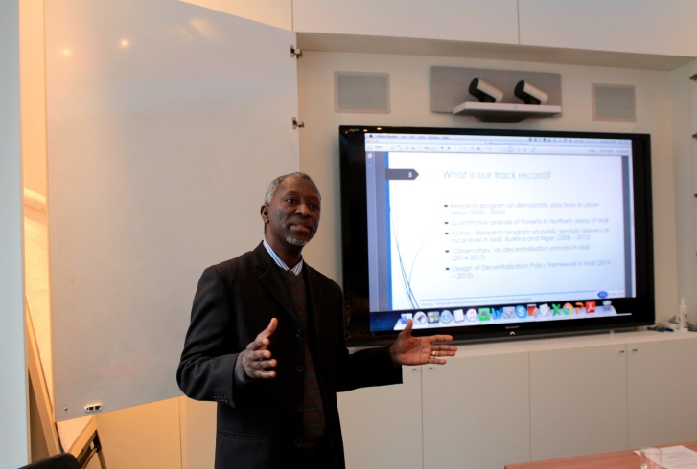
29-01-2016
From 25 to 29 January 2016, the Groupe Observation des Dynamiques Sociales, Spatiales & Expertise Endogène (Groupe ODYSSEE) visited the ECDPM offices for a week of exchanges on policy research best practices.
Groupe ODYSSEE is a Malian organisation that carries out action-oriented research in Africa – and in Mali in particular. It aims to create synergies among different experts across a range of topics. Through scientific contributions, it supports territorial, political, social, economic, technical and cultural changes. The delegation that visited our ECDPM offices was composed by Dr. Amagoin Keita, Executive Director; Dr. Brahima Fomba, Scientific Coordinator; and Mr. Cheick Mohamed Samake, Counselor for local development and decentralisation.
The visit took place in the framework of the “Mécanisme d’Observation de la Décentralisation” (Project MODe), supported by the Netherlands Embassy in Mali. This project aims at providing a better understanding of decentralisation policies in Mali and their consequences on local governance and local dynamics.
Within Project MODe, ECDPM provides support to the institutional development of Groupe ODYSSEE, expertise in policy-relevant research and on communications for policy advocacy.
The specific objectives of the visit included:
- to provide backstopping support to Groupe ODYSSEE’s management team on a number of topics
- the use of Political Economy Analysis (PEA) in policy research
- strategic communication
- regionalisation strategies
- communities of practice and network platforms
- partnership building with European organisations
Last but not least, the visit offered the delegation of the Groupe ODYSEE an opportunity to network with organisations based in the Netherlands and in Brussels.

From 6 to 10 September, ECDPM’s Alfonso Medinilla and Greta Galeazzi visited Groupe ODYSSEE (the Groupe Observation des dynamiques sociales, spatiales & expertise endogène) in Bamako, Mali.
Exchanges touched upon the roles of think tanks and civil society organisations in policy influencing, as well as the potential of applied research for advocacy purposes.
This mission took place within the framework of ECDPM’s collaboration with Groupe ODYSSEE for the Project MODe, which aims at linking research and practice in Mali. ECDPM plays the role of backstopper and facilitator, supporting the strategic and institutional development of Groupe ODYSSEE.
Past exchanges, such as the visit of a Groupe ODYSSEE delegation to ECDPM’s headquarter in Maastricht last January, have already borne their fruits, underlining the importance of ECDPM’s work in supporting civil society in Africa.
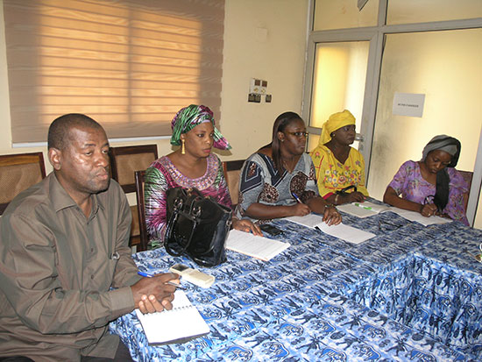
Members of the Groupe ODYSSEE taking part in the four-day event facilitated by ECDPM in Bamako, Mali
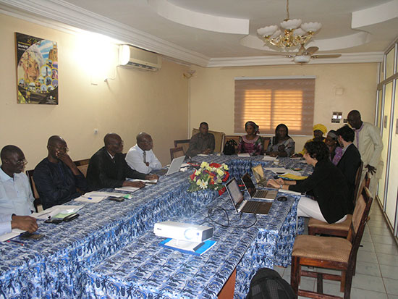
ECDPM’s Greta Galeazzi and Alfonso Medinilla (on the right) facilitating the event

